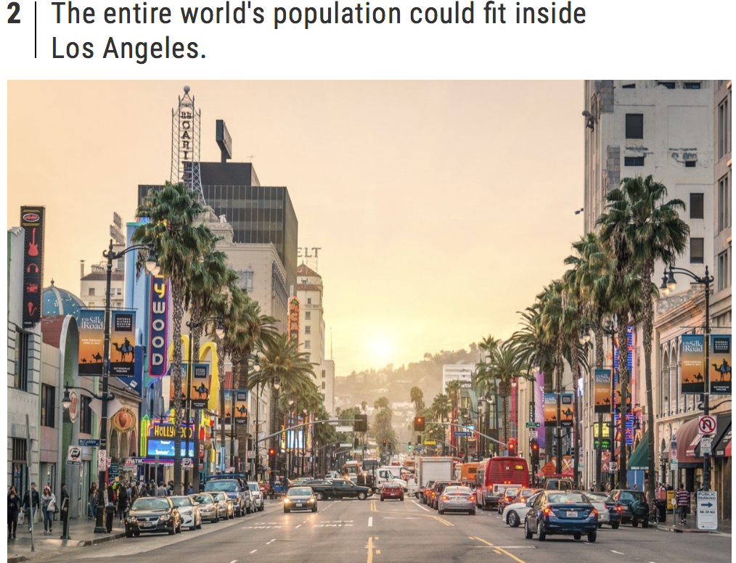
The world's total population is more than 7.5 billion. And obviously, that number sounds huge. However, it might feel a little more manageable once you learn that if every single one of those people stood shoulder-to-shoulder, they could all fit within the 500 square miles of Los Angeles, according to National Geographic.

